IG Physics

Assignment #2

Name: __________

Group: ___

Score: **/20**

Subject Teacher: C. Chu

Due date: Oct. 10th, 2021

1. An aeroplane of mass 2.5 × 105 kg lands with a speed of 62 m / s, on a horizontal runway

at time *t* = 0. The aeroplane decelerates uniformly as it travels along the runway in a straight line until it reaches a speed of 6.0 m / s at *t* = 35 s.

* 1. Calculate the deceleration of the aeroplane in the 35 s after it lands.

deceleration = [2]

* 1. Calculate the resultant force acting on the aeroplane as it decelerates.

force = [2]

* 1. Calculate the momentum of the aeroplane when its speed is 6.0 m / s.

momentum = [2]

[Total: 6]

1. A bus is travelling along a straight road. The bus and the driver have a combined mass of 16 000 kg when there are no passengers in it. The bus has 73 passengers. The average mass of each of the passengers is 65 kg.
   1. Calculate the total mass of the bus, the driver and the 73 passengers.

mass = [2]

* 1. The fully loaded bus accelerates uniformly from rest to a speed of 14 m / s. The time taken to reach a speed of 14 m / s is 20 s.

Calculate the resultant force on the bus during the acceleration.

force = [2]

[Total: 4]

1. A chest expander is a piece of equipment used by athletes in a gym. The diagram shows a chest expander that consists of five identical springs connected in parallel between two handles.

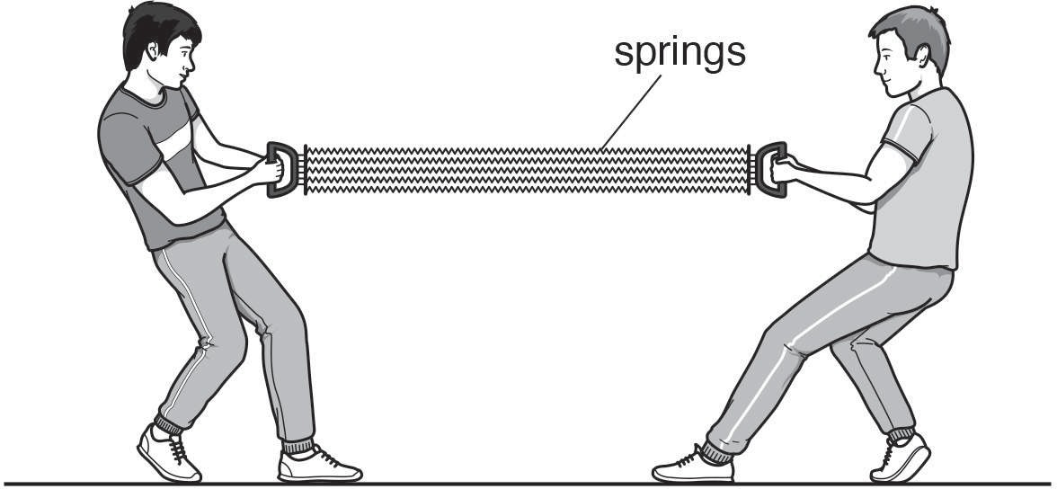

Two athletes are stretching the chest expander by pulling on the two handles in opposite directions. The springs obey Hooke’s law.

Explain what is meant by this statement.

..................................................................................................................................................

..................................................................................................................................................

.................................................................................................................................................. [2]

[Total: 2]

1. A chest expander is a piece of equipment used by athletes in a gym. The diagram shows a chest expander that consists of five identical springs connected in parallel between two handles.



Each spring has an unstretched length of 0.63 m.

Two athletes are stretching the chest expander by pulling on the two handles in opposite directions. Each athlete pulls the handle towards himself with a force of 1300 N.

* 1. State the tension in each spring.

tension = [1]

* 1. The chest expander stretches and each spring is now 0.94 m long.

Calculate the spring constant *k* of each spring.

*k* = [2]

[Total: 3]

1. The diagram shows a model fire engine. Its brakes are applied.

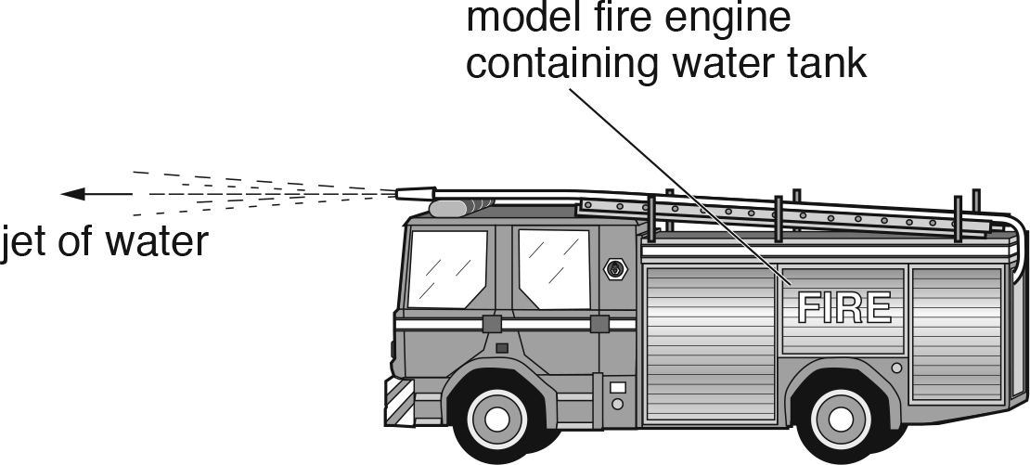

0.80 kg of water is emitted in the jet every 6.0 s at a velocity of 0.72 m / s relative to the model.

1. The brakes of the model are released.

State and explain the direction of the acceleration of the model.

Statement .........................................................................................................................

Explanation .......................................................................................................................

........................................................................................................................................... [2]

1. In **(a)** the model contains a water tank, which is initially full.

State and explain any change in the magnitude of the initial acceleration if the brakes are first released when the tank is nearly empty.

Statement .........................................................................................................................

Explanation .......................................................................................................................

...........................................................................................................................................

........................................................................................................................................... [3]

[Total: 5]